Lab 10: Managing HDFS SnapShots

Objective: To use HDFS command-line utilities and NameNode UI to create and manage HDFS snapshots

[root@golden-node1 ~]# su – hdfs

[hdfs@golden-node1 ~]$ hdfs dfsadmin -allowSnapshot /user/root

[hdfs@golden-node1 ~]$ hdfs lsSnapshottableDir

* dfsadmin command with the -allowSnapshot option to enable snapshots on the /user/root directory

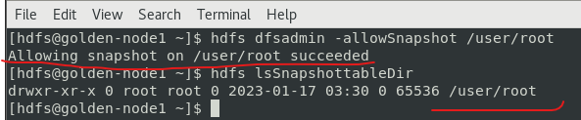

[hdfs@golden-node1 ~]$ exit

Managing SnapShots

* Create, view, rename, explore, and delete an HDFS snapshot.

[root@golden-node1 ~]# hdfs dfs -ls /user/root/.snapshot

[root@golden-node1 ~]# hdfs dfs -createSnapshot /user/root

[root@golden-node1 ~]# hdfs dfs -ls /user/root/.snapshot

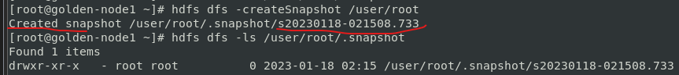

[root@golden-node1 ~]# hdfs dfs -renameSnapshot /user/root s20230117-204615.000 mysnap

[root@golden-node1 ~]# hdfs dfs -ls /user/root/.snapshot



[root@golden-node1 ~]# hdfs dfs -ls /user/root

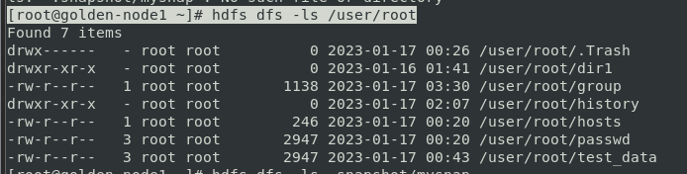

[root@golden-node1 ~]# hdfs dfs -put /usr/hdp/3.1.0.0-78/hadoop-mapreduce/hadoop-mapreduce-examples.jar /user/root/hadoop-mapreduce-examples

[root@golden-node1 ~]# hdfs dfs -ls /user/root

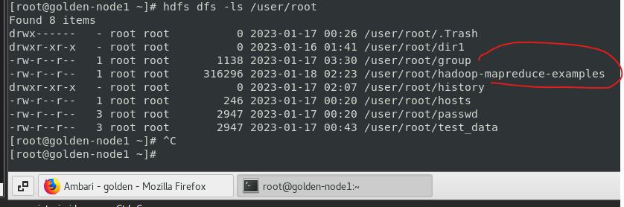

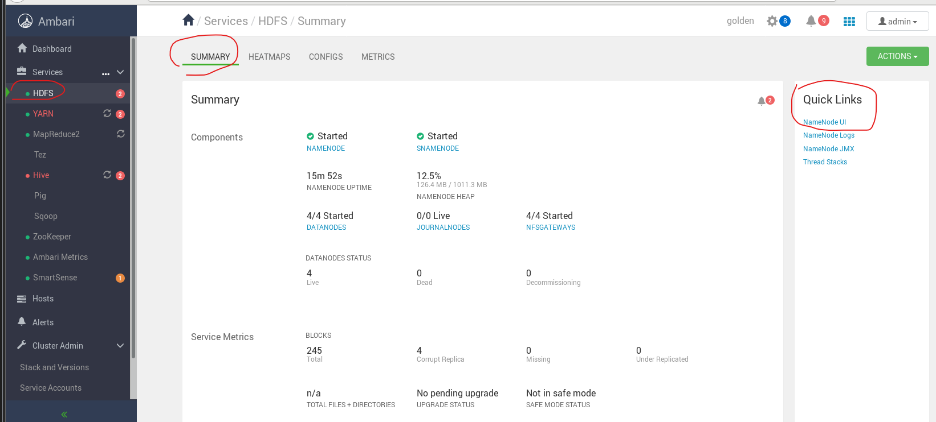

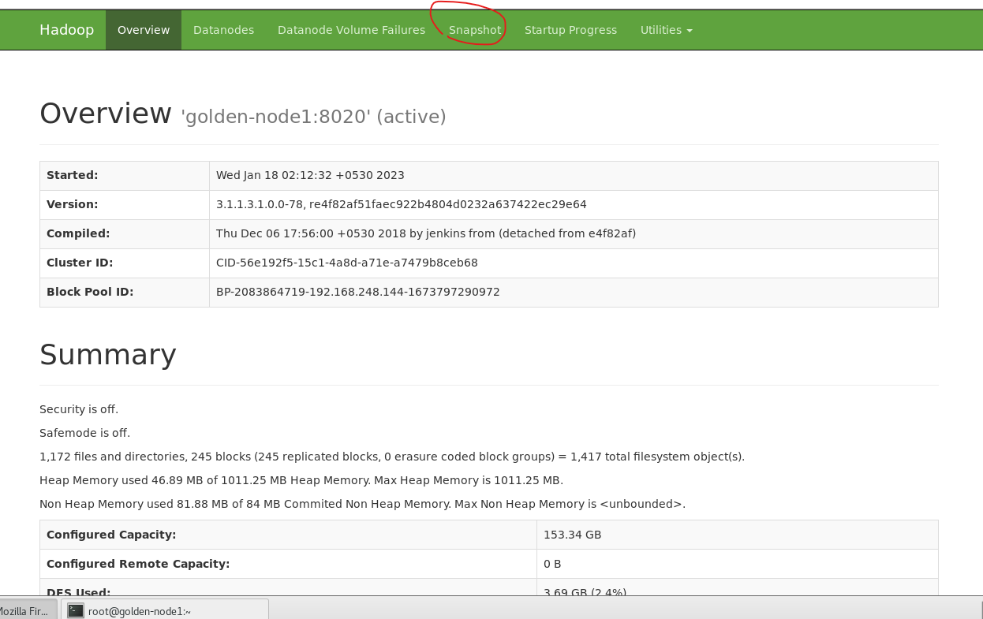

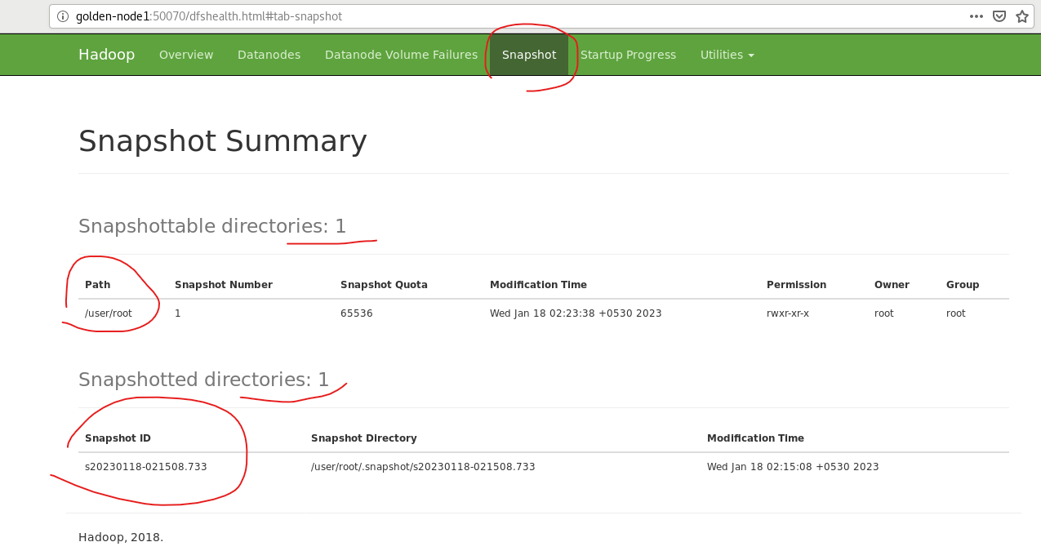

Delete SnapShot:

[root@golden-node1 ~]# hdfs dfs -ls /user/root/.snapshot

